Random Password Generator
1-Page Summary Report • Extended Python Project

Problem Statement
Build a configurable Random Password Generator that produces secure passwords mixing uppercase, lowercase, digits and symbols. The solution must accept user-controlled length and character-class flags, enforce a minimum length, optionally guarantee at least one character from every selected class, evaluate password strength, and support both classic random and cryptographically-secure (secrets) generation. A Monte-Carlo simulation explores how strength and entropy scale with length and options.

Solution Strategy
- Character-pool builder (build_charset) that respects upper/lower/digit/symbol flags and optional ambiguous-character exclusion.
- Core generator (generate_password) that first injects one character per selected pool (when ensure_each=True), fills the rest with random.choices / secrets.choice, then shuffles.
- Strength scorer combining length bands with diversity count, tempered by the book’s length guideline (<6 Weak, 6-10 Medium, >10 Strong).
- Parameterised Monte-Carlo (N≈800) that plots average score, % Strong, entropy and overall score distribution versus length.

Solution
Key functions implemented: build_charset, generate_password (with secure flag), assess_strength, generate_batch, and two alternate coding styles (dictionary-driven pure-choice loop and secrets-only list-comprehension). Sample reproducible outputs (seed=42):
len=8 → '(0NJU<Xd' [Medium] len=12 → strong mixed password len=16 → Strong
Simulation (ensure_each=True, full charset) shows a clear transition: average score rises from ~4 at length 6 to 10 at length 16; % Strong jumps from 0 % (L≤10) to 100 % (L≥12). Entropy scales linearly, exceeding 70 bits by length 12.
Simulation Charts
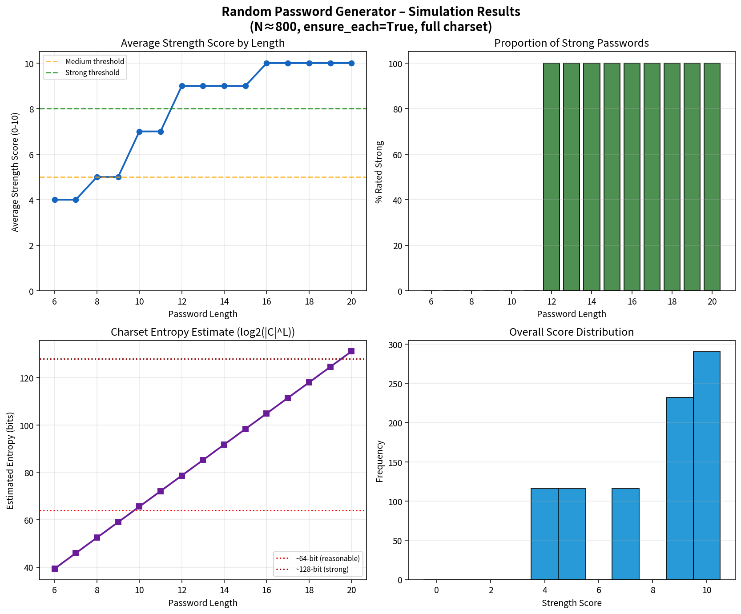

Key Takeaways
- Always guarantee character-class diversity when length permits; otherwise a password can still be long yet weak.
- Prefer the secrets module for any production generator – random is fine for teaching, not for real credentials.
- Length remains the dominant security lever once diversity is assured; aim for ≥12–16 characters from a full printable set.
- Simulation makes the strength-vs-length relationship concrete and lets learners instantly test design trade-offs (symbols on/off, ambiguous exclusion, etc.).
- Deliverables: Practice Skeleton + Solution notebooks, flowchart, simulation chart, standalone .py module, and this summary.

